# Database Design Requirements

## Client: Carlotta Antique Jewellery

Document Prepared By: Lance Flatman

## Requirements brief

To create a database to record antique jewelry sales information and allow Carlotta to utilise this to improve decision making and operations of the business. The database system to be implemented is Microsoft SQL Server 2014 and will handle the various transactions required, will scale with time if required and incorporates security processes covering both user and role levels of protection. A challenge which might occur is the accurate recording of details relating to the sale of Carlotta’s products but the implementation of the database system should improve on this.

The database will allow Carlotta to manage a mailing list of customers who wish to receive her newsletter, provide a list of sales by item type or by customer segment and the sales by month, while reducing duplication and errors. To provide immediate benefits for the reports detailed it would be advised to enter Customer information for the previous 6 months into the system (from January 2016) and possibly Sales details for the same period.

## Entity relationship diagram

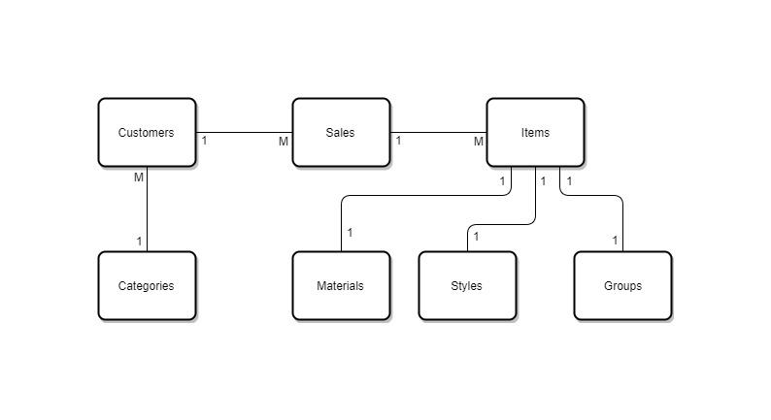

## Normalisation issues

1. Repeating Customer Information – several sales to John Smith / Mary Jones (with same address) (1NF)
2. Repeating information within Item Description – Diamond Ring / Gold Broach (1NF)
3. Repeating information by Item Type – Mens Jewellery / Womens Jewellery / Mens Watch / Womens Watch (1NF)
4. Repeating information by Category – e.g. 30-39 / 40-49 etc. (1NF)
5. Duplicate entries within the Item Description – e.g. Diamond Ring / Gold Broach (2NF)
6. Duplicate Attributes within the Item Types – Mens Jewellery / Womens Jewellery / Mens Watch / Womens Watch (2NF)
7. Each item of Jewellery is unique but the Materials / Styles repeat - Materials (Diamond / Gold / Pearl / Silver) and Styles (Earrings / Ring / Broach / Bracelet / Necklace / Watch) (3NF)
8. Item Type can be split into Gender (Men / Women – possibly unisex) and Groups (Jewellery / Watch – may potentially increase in number if the business expands into other areas) (3NF)

After investigating the sample data, it has been noted there are several information recording issues. These relate to Data Integrity (DI) and Data Redundancy (DR) issues and can potentially be eliminated by the implementation of a database for the recording of the businesses information: -

1. Send newsletter shows alternate results for the same people (John Smith and Mary Jones has once of each Yes and No) or is missing the information (the second John Smith is showing blank) (DI)
2. Categories has an incorrect group entered (40-48 should be 40-49) (DI)
3. Mary Jones is assigned to two groups within the Categories information (Under 18 and 26-29) (DI)
4. Year 3 and Price 3 Column information has been incorrectly entered in the wrong columns (DI)
5. Amount is incorrectly recorded for Mary Jones (6 June) – Items add up to $4,800 and the Total is showing as $4,500 (DI)
6. Items are sometimes missing from the Item 1 column but appear in the Item 2 column (Margaret Wilson / Mary Jones) or Item 2 missing and information is in Item 3 (John Smith) (DI)
7. Postcode is different for the two Surrey Hills addresses (Margaret Wilson / Sandra Kindale) (DI)
8. The Suburb of Leichardt for John Smith and is spelt incorrectly within the Address field (DI)
9. Amount column is not required as it can be calculated from the Price 1, Price 2 and Price 3 columns (DR)
10. Address information for John Smith at Sunnydale St is spelt differently between the two entries (Capitals on one and lowercase on the other). This could be corrected by recording the customer details once. (DI / DR)
11. As noted, if someone purchases more than 3 items in the one day, this would require recording on multiple rows presently (DR)

Future Improvement recommendations: -

1. The database could be utilised to identify a potential customer whom may purchase a type of item (e.g. Pearl / Diamond) or style (e.g. Ring / Necklace) on a repeat basis. Use this information to target those Customers when a specific item is sourced to improve stock turnover.
   1. Record a Customer’s contact phone number to enable a courtesy call if an item comes in for the above example.
2. Record a customer’s email address and send out the catalogues in an electronic format. This may reduce operating costs and free up Carlota’s time in other ways, increase the speed of informing existing customers and potentially increase stock turnover.
3. Maintain notes within the Customer record if they have made a request for something (such as ‘Can you assist with repairing an item?’ / ‘How much do you think this item is worth?)
   1. This might lead to an additional income stream from the existing customer base.
4. Record details of items purchased such as date, price and seller’s details. This could be used for additional analysis relating to margins, profitability and stock turnover based upon year crafted as Carlotta generally purchases items earlier than 1940. This additional information might be used to determine if the items purchased after this period are more profitable than those from earlier time periods.

The above improvements can be looked at once the database is live and results are generated.

## Database diagram



Please note: On the original submission, the following item was overlooked: -

Customers table: SendNewsletter field– On review of the data this has been included and detailed above in the updated Database Diagram.

## Approval

Name: _____________________________ Date: ___/___/______